**DAILY ONLINE ACTIVITIES SUMMARY**

|  |  |  |  |  |  |  |  |  |
| --- | --- | --- | --- | --- | --- | --- | --- | --- |
| **Date:** | **01/06/2020** | | | | | **Name:** | **PRANEETA P HANDRAL** | |
| **Sem & Sec** | **4​th​ SEM. & ‘B’ SEC.** | | | | | **USN:** | **4AL19CS401** | |
| **Online Test Summary** | | | | | | | | |
| **Subject** | | **COMPLEX ANALYSIS ,PROBABILITY AND STATISTICAL METHODS** | | | | | | |
| **Max. Marks** | | **30** | | **Score** | | | **29** | |
| **Certification Course Summary** | | | | | | | | |
| **Course** | **PYTHON FOR MACHINE LEARNING** | | | | | | | |
| **Certificate Provider** | | | **Greatlearning academy** | | **Duration** | | | **5 Hrs.** |
| **Coding Challenges** | | | | | | | | |
| **Problem Statement:** **Given an array arr[] of size N and an integer K. The task is to find the count of subarrays such that each subarray has exactly K distinct elements.**  **Problem Statement:**  **Define a class Point with two fields x and y each of type double. Also , define a method distance(Point p1, Point p2) to calculate the distance between points p1 and p2 and return the value in double.. Use Math. sqrt( ) to calculate the square root.** | | | | | | | | |
| **Status:** **Executed.** | | | | | | | | |
| **Uploaded the report in Github** | | | | | **Yes** | | | |
| **If yes Repository name** | | | | | **LockdownCoding** | | | |
| **Uploaded the report in slack** | | | | | **Yes** | | | |

**Online Test Summary:** 18MAT41 online test was scheduled from 9:30 am t0 10 am And the test scores is 29.The portion for the IA was 5th module there were 30 questions and the time assigned was 40minutes the questions were MCQ type. There is 2 rounds in first round have 10 question each carries 1 marks 2 round carries 10 questions each questions carries 2 marks respectively.

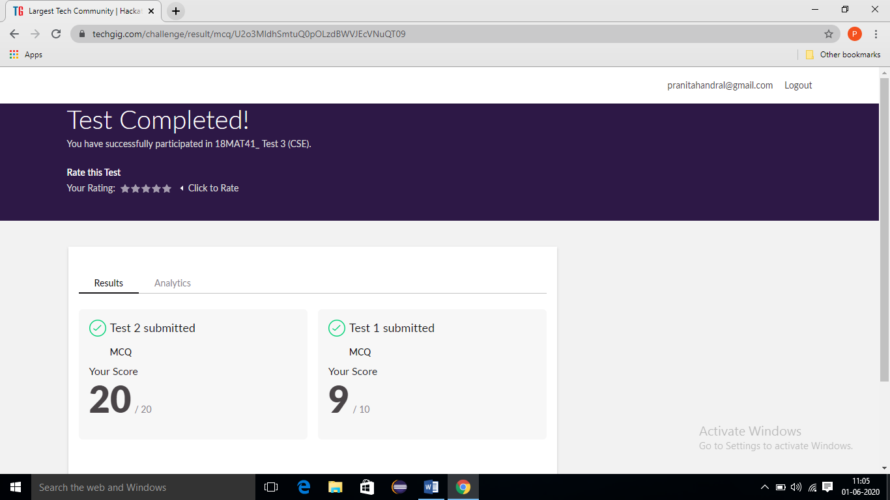

**Online Certification course Summary​: Today I have learn about some other Pandas - Functions and also execute the some of the basic function programs .**

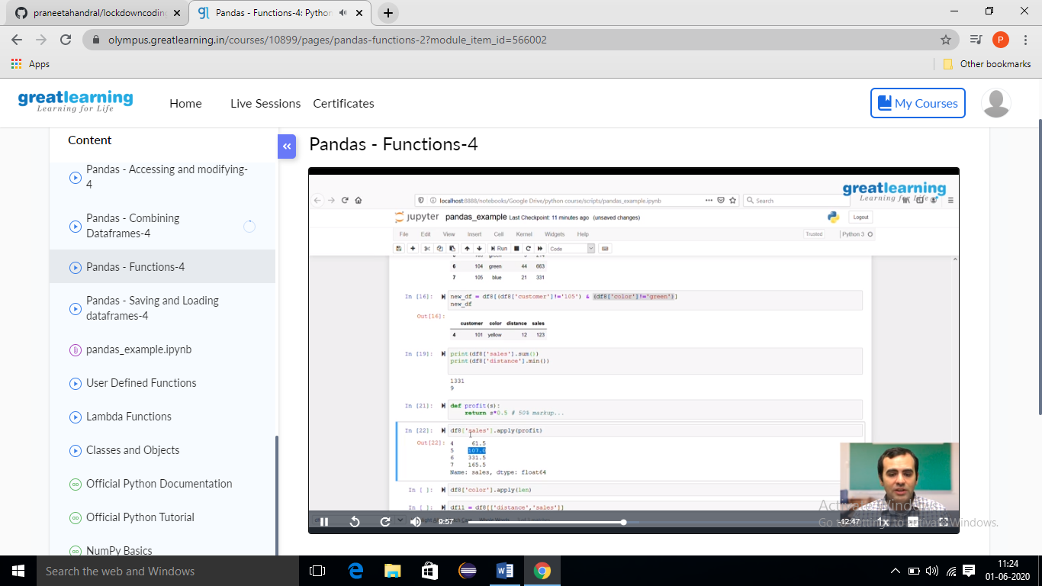

**Online Coding Summary​:** Today I received two programs from prof.Venkatesh CSE Dept. The ONE programs were i) write a program to print the frequency of each character in a string.“Hello friend”. I have written one program and uploaded it to my Github repository

This is my repository snapshot. I have uploaded the frequency program.

